
Projector
Sharp visuals, compelling value

P1276
- XGAresolution and 3500 lumens brightness for brilliant imagery
- Ready for hassle-free enjoyment of 3D games and movies
- Acer EcoProjection lowers power consumption by up to 75%
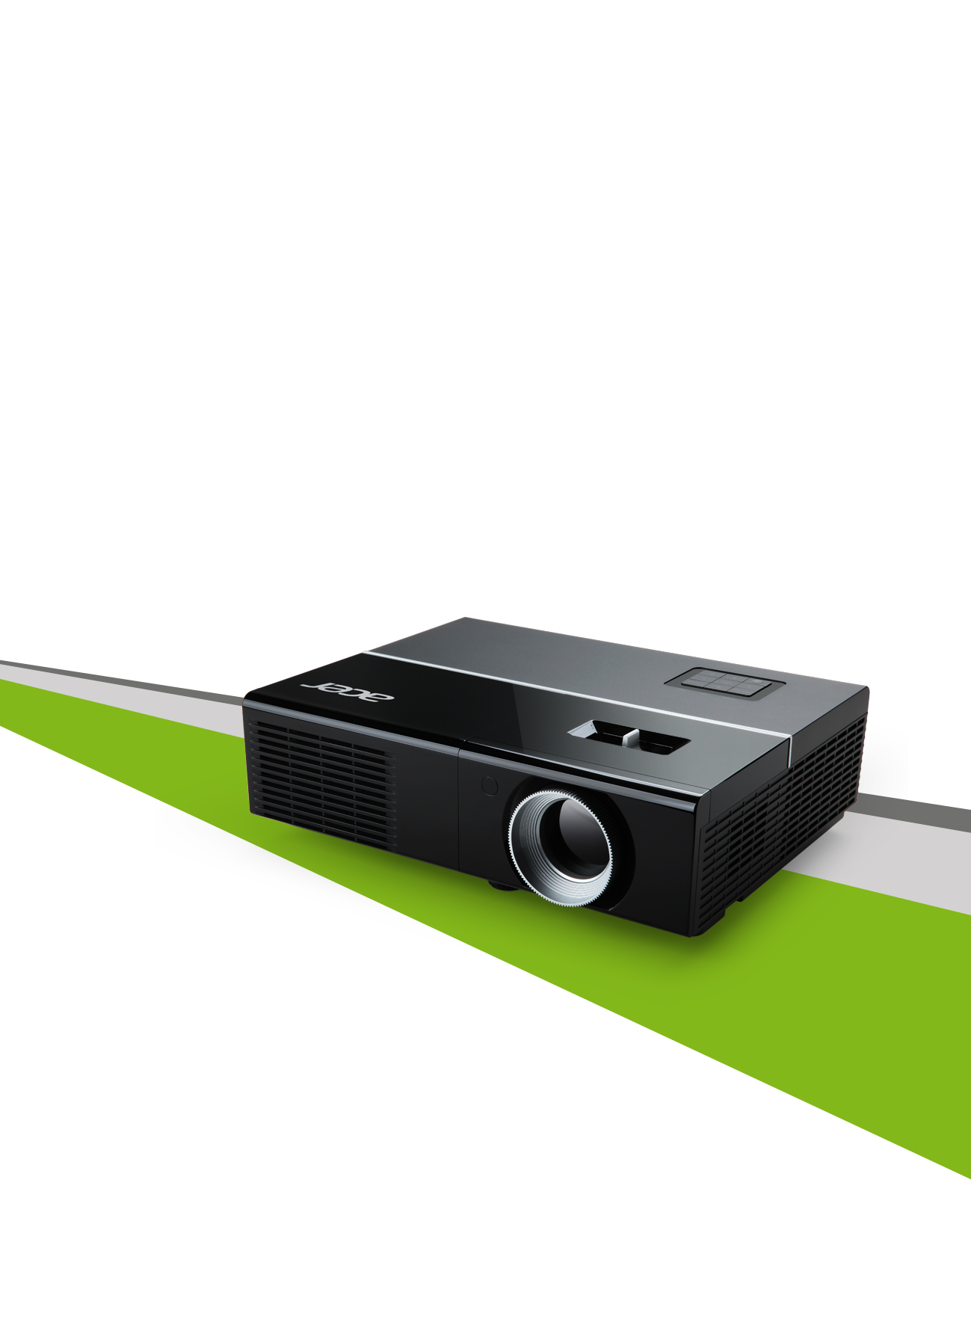

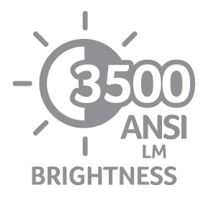 | 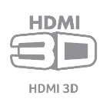 |  |  |  | 

 |  | 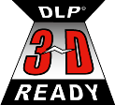 | 
Feature Highlights
Captivating projection
- Acer ColorBoost II+
- Acer ColorSafe II
- DLP® 3D Ready (Blu-ray Disc™)
- Supports HDMI® 3D
- Native XGA (1024 x 768) resolution
- 3500 lumens, 13,000:1 contrast ratio
Enhanced usability
- Acer Empowering Technology
- HDMI®connectivity
- Digital zoom and pan
- Built-in speaker
- Acer SmartFormat
- PINsecurity
- Closed captioning
- True 24p film support (HDMI®)
- Quick start
- Instant resume
- Instant pack
- One Button 3D
Installation flexibility
- Acer top-loading lamp design
- Installation menu (onboard OSD)
- Auto ceiling-mount correction
- Multi-PC connectivity (HDMI®)
- Dual D-Sub input
- Auto keystone correction
- RS-232 control port
- High-altitude mode
- Wall-color compensation
Eco-friendly functionality
- Acer EcoProjection technology
- Lamp life up to 7,000 hours
in ExtremeEco mode
- ECO mode
- Auto shutdown
- Low noise level
Specifications
Model name | Acer P1276
Projection system | DLP®
Resolution | Native XGA (1024 x 768)  Maximum UXGA (1600 x 1200), WUXGA (1920 x 1200)
Aspect ratio | 4:3 (native), 16:9
Contrast ratio | 13,000:1
Brightness | 3500 ANSI lumens (standard); 2800 ANSI lumens (ECO)
Lamp life | 3500 hours (standard); 5000 hours (ECO); 7000 hours (ExtremeEco)
Projection lens | F = 2.41 - 2.55, f = 21.79 - 23.99 mm  1:1.1 manual zoom and manual focus
Keystone correction | +/-40 degrees (vertical), manual and auto
Noise level | 34dBA (standard); 30dBA (ECO)
Input interface | Analog RGB / Component video (D-sub) x 2  Composite video (RCA)  S-video (Mini DIN)  HDMI® (video, audio, HDCP)  PC audio (stereo mini jack)
Output interface | Analog RGB (D-sub)  PC Audio (stereo mini jack)
Control interface | USB (mini-B)  RS-232 (Mini DIN)
Dimensions | 288 x 225 x 83 mm (11.3" x 8.9" x 3.3")
Weight | 2.4 kg (5.3 lbs.)
About Acer
Established in 1976, Acer is an information and communication technology company dedicated to the research, design, marketing, sale and support of innovative products that enhance people's lives. Acer's green supply chain delivers environmentally friendly PCs, displays, projectors, servers, tablets and smartphones — tools our customers need to explore beyond limits and experience more. Ranked No. 3 for notebooks globally (IDC 2012), Acer employs 8,000 people, and 2012 revenues reached US$14.7 billion. Please visit www.acer.com for more information.
Acer ColorBoost II+ Technology
ColorBoost II+ is an advancement that refines the form of light waves to improve color performance based on lamp spectrum and color-wheel properties. Acer ColorBoost II+ enriches natural color temperature to achieve optical color balance, and enhances content-based color brightness.

Acer ColorSafe II
Acer projectors that feature ColorSafe II are virtually immune to color decay – the yellow or green tint of images displayed by some projectors that have been used for extended periods of time. Acer projectors with ColorSafe II take advantage of DLP® technology and Acer's unique optics-based color-compensation technology to guarantee picture integrity even after prolonged use. The resulting extended lifespan and consistent image quality lower the total cost of ownership.
Acer EcoProjection
Acer EcoProjection is a complete environment-friendly power management solution that reduces standby power consumption by up to 75%. Also featured in the Acer EcoProjection suite is Acer ePower Management for customized power-saving configurations.
DLP® 3D Ready
This projector supports DLP® 3D glasses for viewing in 3D any 120 Hz frame-sequential 3D content from a PC with a 120 Hz graphics card and 3D stereoscopic player.

